34.Design DFA using simulator to accept even number of c’s over the set {a,b,c}

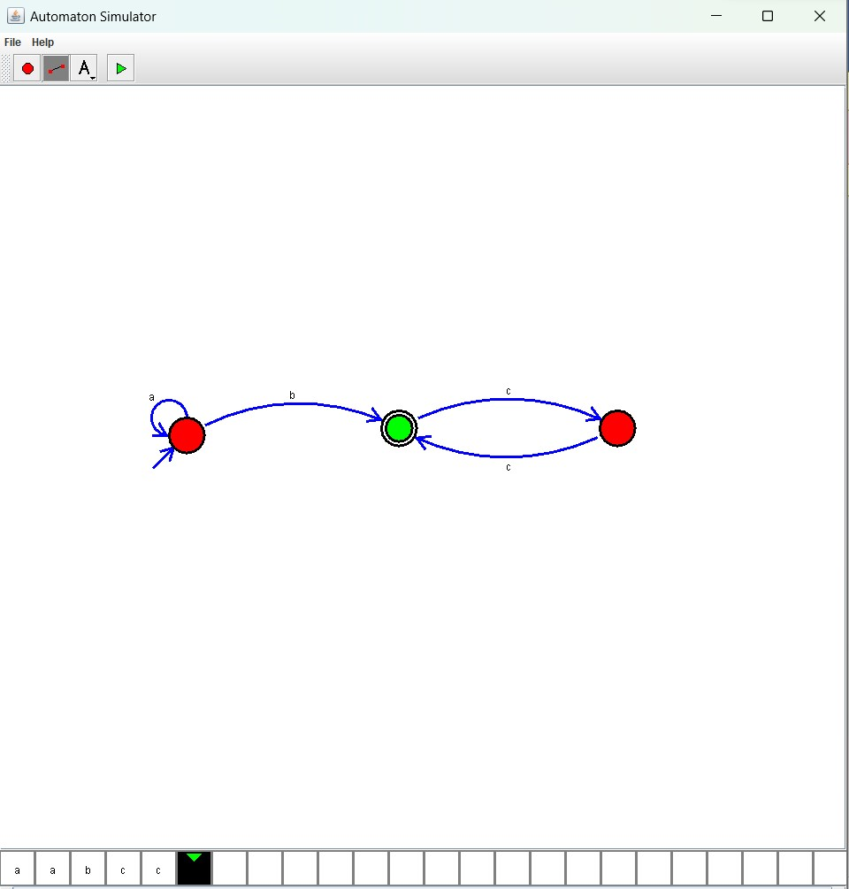

Result :

The simulator is accepted the even number of c’s over the set {a,b,c} by using the above DFA diagram